

Semester One Examination, 2020

Question/Answer Booklet

MATHEMATICS
METHODS
ATAR Year 12
Section Two:
Calculator-assumed

Student Name: ______________________________________________________

Please circle your teacher’s name
Teacher: Miss Long Miss Rowden Ms Stone

Time allowed for this paper
Reading time before commencing work: 10 minutes
Working time for paper: 100 minutes

Materials required/recommended for this paper
To be provided by the supervisor
Number of additional
answer booklets used
(if applicable):
This Question/Answer Booklet
Formula Sheet (retained from Section One)

To be provided by the candidate
Standard items: pens (blue/black preferred), pencils (including coloured), sharpener, correction fluid/tape, eraser, ruler, highlighters
Special items: drawing instruments, templates, notes on two unfolded sheets of A4 paper, and up to three calculators approved for use in this examination

Important note to candidates
No other items may be taken into the examination room. It is your responsibility to ensure that you do not have any unauthorised material. If you have any unauthorised material with you, hand it to the supervisor before reading any further.
Structure of this paper
Section | Number of questions available | Number of questions to be answered | Suggested working time (minutes) | Marks available | Percentage of examination
Section One:  Calculator free | 8 | 8 | 50 | 52 | 35
Section Two:  Calculator-assumed | 13 | 13 | 100 | 97 | 65
 |  |  |  | Total | 100

Instructions to candidates
- The rules for the conduct of the ATAR course examinations are detailed in the Year 12 Information Handbook 2020. Sitting this examination implies that you agree to abide by these rules.

- Write your answers in this Question/Answer booklet.

- You must be careful to confine your answers to the specific questions asked and to follow any instructions that are specific to a particular question.

- Supplementary pages for the use planning/continuing your answer to a question have been provided at the end of the Question/Answer booklet. If you use these pages to continue an answer, indicate at the original answer where the answer is continued, i.e. give the page number.

- Show all your working clearly. Your working should be in sufficient detail to allow your answers to be checked readily and for marks to be awarded for reasoning. Incorrect answers given without supporting reasoning cannot be allocated any marks. For any question or part question worth more than two marks, valid working or justification is required to receive full marks. If you repeat any question, ensure that you cancel the answer you do not wish to have marked.

- It is recommended that you do not use pencil, except in diagrams.

- The Formula sheet is not to be handed in with your Question/Answer booklet.

Section Two: Calculator-assumed 65% (97 Marks)

This section has thirteen (13) questions. Answer all questions. Write your answers in the spaces
provided.

Supplementary pages for the use of planning/continuing your answer to a question have been provided at the end of this Question/Answer booklet. If you use these pages to continue an answer, indicate at the original answer where the answer is continued, i.e. give the page number.

Working time: 100 minutes.

Question 9 (4 marks)
The graphs of $y=\cos^{2}\left(x+\frac{π}{6}\right)$ and $y=\frac{3}{4}$ are shown below. Determine the exact area of the shaded region they enclose.
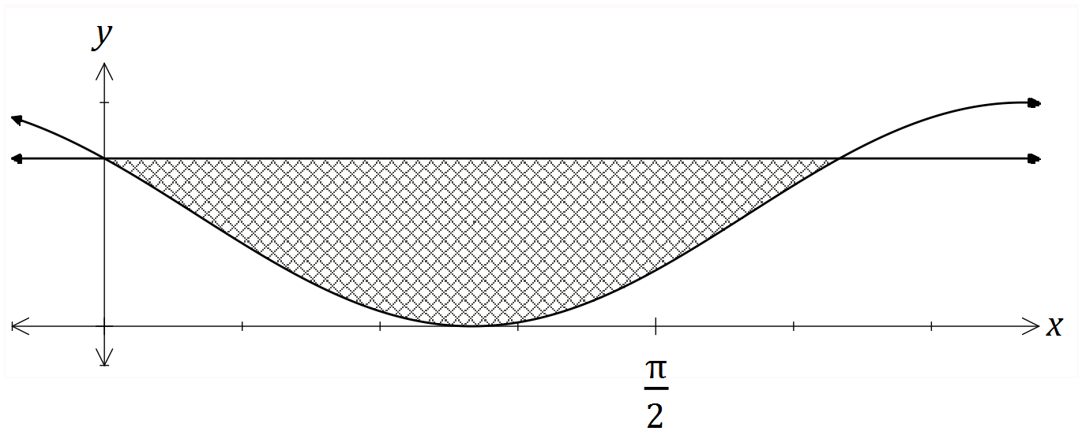

Question 10 (8 marks)
A small body moving in a straight line has displacement $x$ cm from the origin at time $t$ seconds given by
$$x=8\cos\left(0.5t-2\right)+1.5, 0≤t≤12.$$

(a) Use derivatives to justify that the maximum displacement of the body occurs when $t=4$.
(4 marks)

(b) Determine the time(s) when the velocity of the body is not changing.
(2 marks)

(c) Express the acceleration of the body in terms of its displacement $x$.
(2 marks)

Question 11 (8 marks)
The voltage, $V$ volts, supplied by a battery $t$ hours after timing began is given by
$$V=8.95e^{-0.265t}$$

(a) Determine

- the initial voltage.
(1 mark)

- the voltage after $3$ hours.
(1 mark)

- the time taken for the voltage to reach $0.03$ volts.
(1 mark)

(b) Show that $\begin{matrix}dV \\ \overline{dt}\end{matrix}=aV$ and state the value of the constant $a$.
(2 marks)

(c) Determine the rate of change of voltage $3$ hours after timing began.
(1 mark)

(d) Determine the time at which the voltage is decreasing at $5\%$ of its initial rate of decrease.
(2 marks)

Question 12 (7 marks)
The function $f$ is defined as $f\left(x\right)=\begin{matrix}5e^{0.125x} \\ \overline{ x }\end{matrix} , x>0$, and the graph of $y=f(x)$ is shown below.
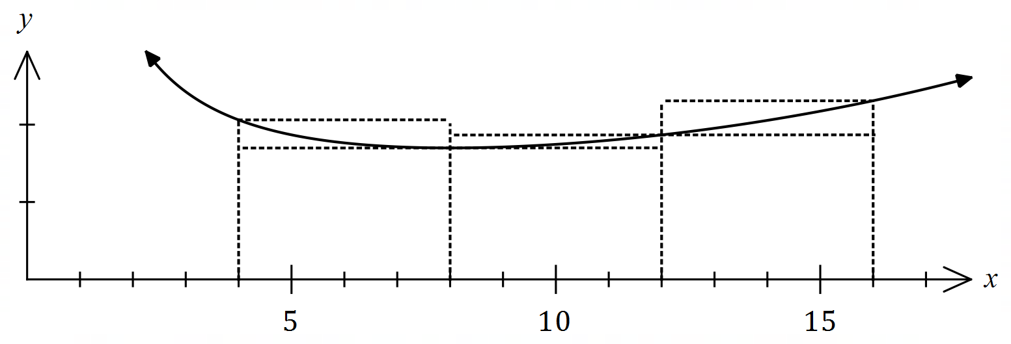
(a) Complete the missing values in the table below, rounding to $2$ decimal places.
(1 mark)
$$x$$ | $$4$$ | $$8$$ | $$12$$ | $$16$$
$$f(x)$$ |  | $$1.70$$ | $$1.87$$

(b) Use the areas of the rectangles shown on the graph to determine an under- and over-estimate for $\int_{4}^{16}{\underset{ }{\overset{ }{f(x)}}}dx$.
(3 marks)

(c) Use your answers to part (b) to obtain an estimate for $\int_{4}^{16}{\underset{ }{\overset{ }{f(x)}}}dx$.
(1 mark)

(d) State whether your estimate in part (c) is too large or too small and suggest a modification to the numerical method employed to obtain a more accurate estimate.
(2 marks)

Question 13 (7 marks)
Functions $f$ and $g$ are such that

$$f\left(4\right)=2, f^{'}\left(x\right)=18{\left(3x-10\right)}^{-2}$$

$$g\left(-4\right)=2, g^{'}\left(x\right)=18{\left(3x+10\right)}^{-2}$$

(a) Determine $f(6)$.
(3 marks)

(b) Use the increments formula to determine an approximation for $g(-3.98)$.
(3 marks)

(c) Briefly discuss whether using the information given about $f$ and the increments formula would yield a reasonable approximation for $f(6)$.
(1 mark)

Question 14 (9 marks)
A small body leaves point $P$ and travels in a straight line for $24$ seconds until it reaches point $Q$. The velocity $v$ m/s of the body is shown in the graph below for $0≤t≤24$ seconds.

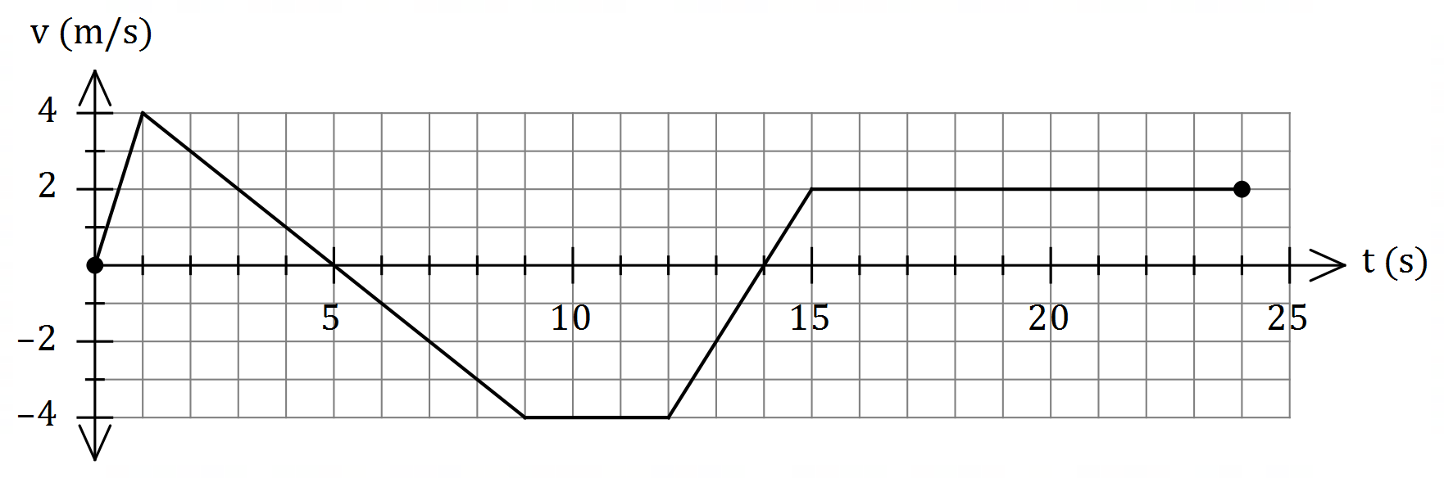

(a) Use the graph to evaluate $\int_{0}^{5}{\underset{ }{\overset{ }{v}}}dt$ and interpret your answer with reference to the motion of the small body.
(3 marks)

(b) Determine an expression, in terms of $t$, for the displacement of the body relative to $P$ during the interval $1≤t≤9$.
(3 marks)

(c) Determine the time(s) at which the body was at point $P$ for $0<t≤24$.
(3 marks)

Question 15 (9 marks)
A curve has equation $y=\left(x-3\right)e^{2x}$.
(a) Show that the curve has only one stationary point and use an algebraic method to determine its nature.
(3 marks)

(b) Justify that the curve has a point of inflection when $x=2$.
(4 marks)

(c) Sketch the curve on the axes below.
(2 marks)

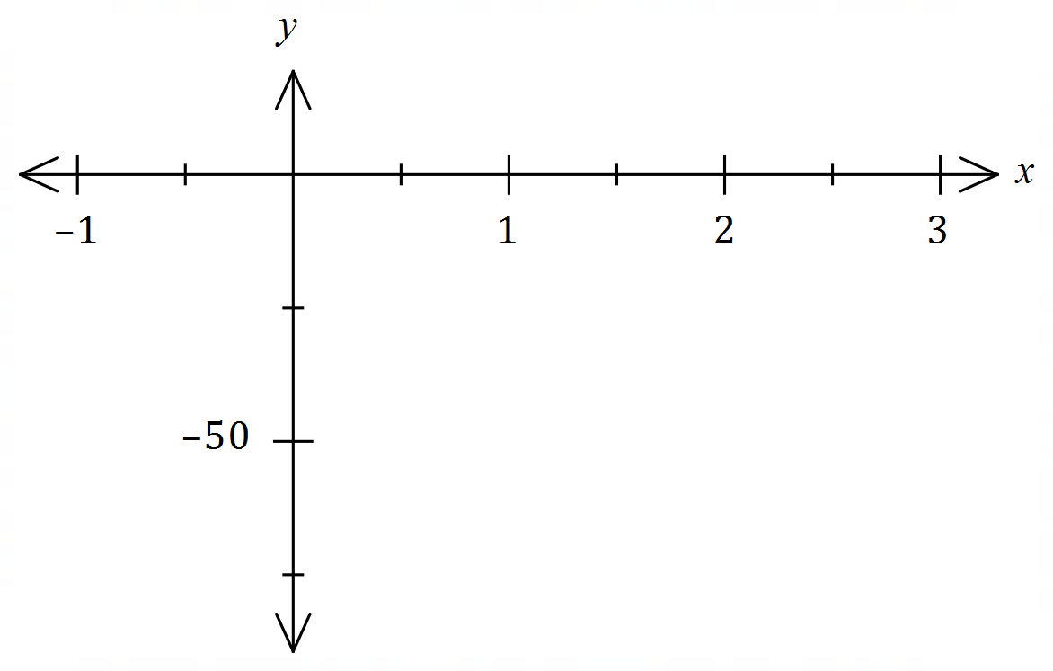

Question 16 (8 marks)
Let $P(a, b)$ be a point in the first quadrant that lies on the curve $y=5-x^{2}$ and $A$ be the area of the triangle formed by the tangent to the curve at $P$ and the coordinate axes.

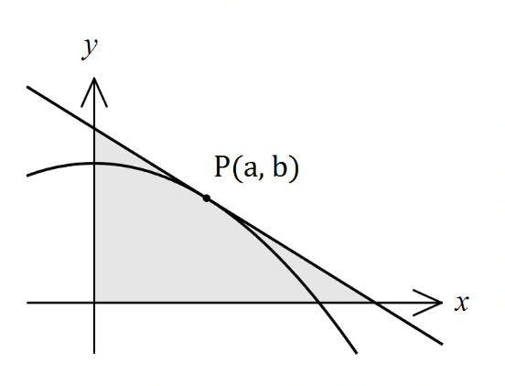

(a) Show that $A=\begin{matrix}{\left(a^{2}+5\right)}^{2} \\ \overline{ 4a }\end{matrix}$.
(4 marks)

(b) Use calculus to determine the coordinates of $P$ that minimise $A$.
(4 marks)

Question 17 (8 marks)
(a) The cost of producing x items of a product is given by . Each item is sold for $24.90.

- Determine the profit equation.
(1 mark)

- Use differentiation to determine the profit associated with the sale of the 1001st item.
(3 marks)

(b) Use the increments formula to determine the percentage change in the radius of a cone if the height remains constant and V increases by 3%. (4 marks)

Question 18 (9 marks)
(a) The rule of the graph below is of the form $y=\log_{2}\left(x-b\right)+c$.
(2 marks)

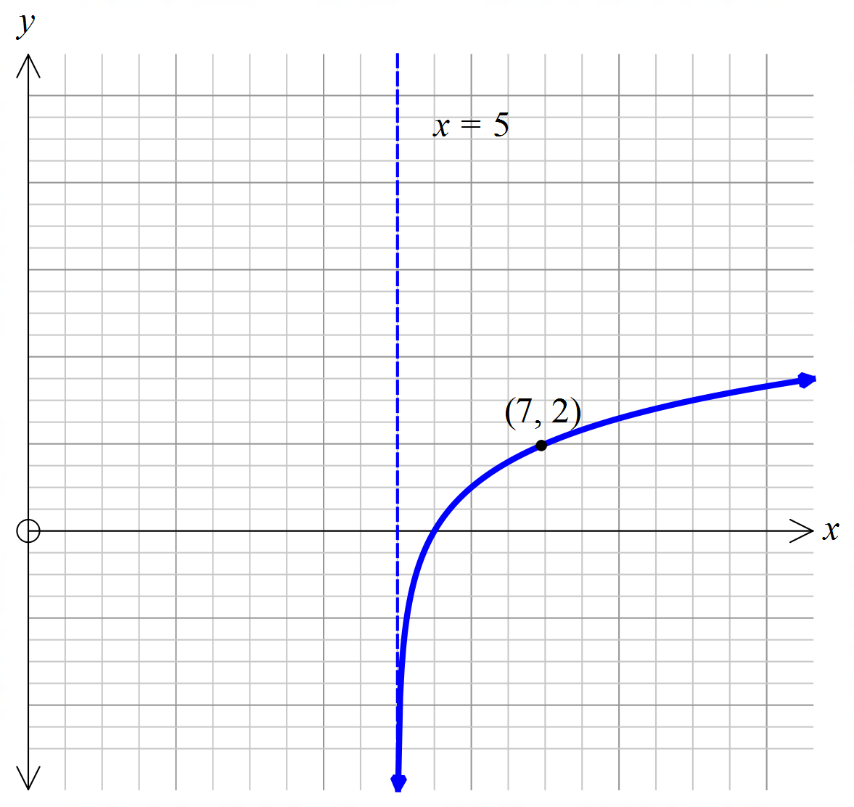

Find the values of $b$ and $c$.

(b) Draw the graph of the function in the form $y=\log_{3}\left(x-b\right)+c$ which passes through the points (5, 10) and (-1, 9).
(3 marks)
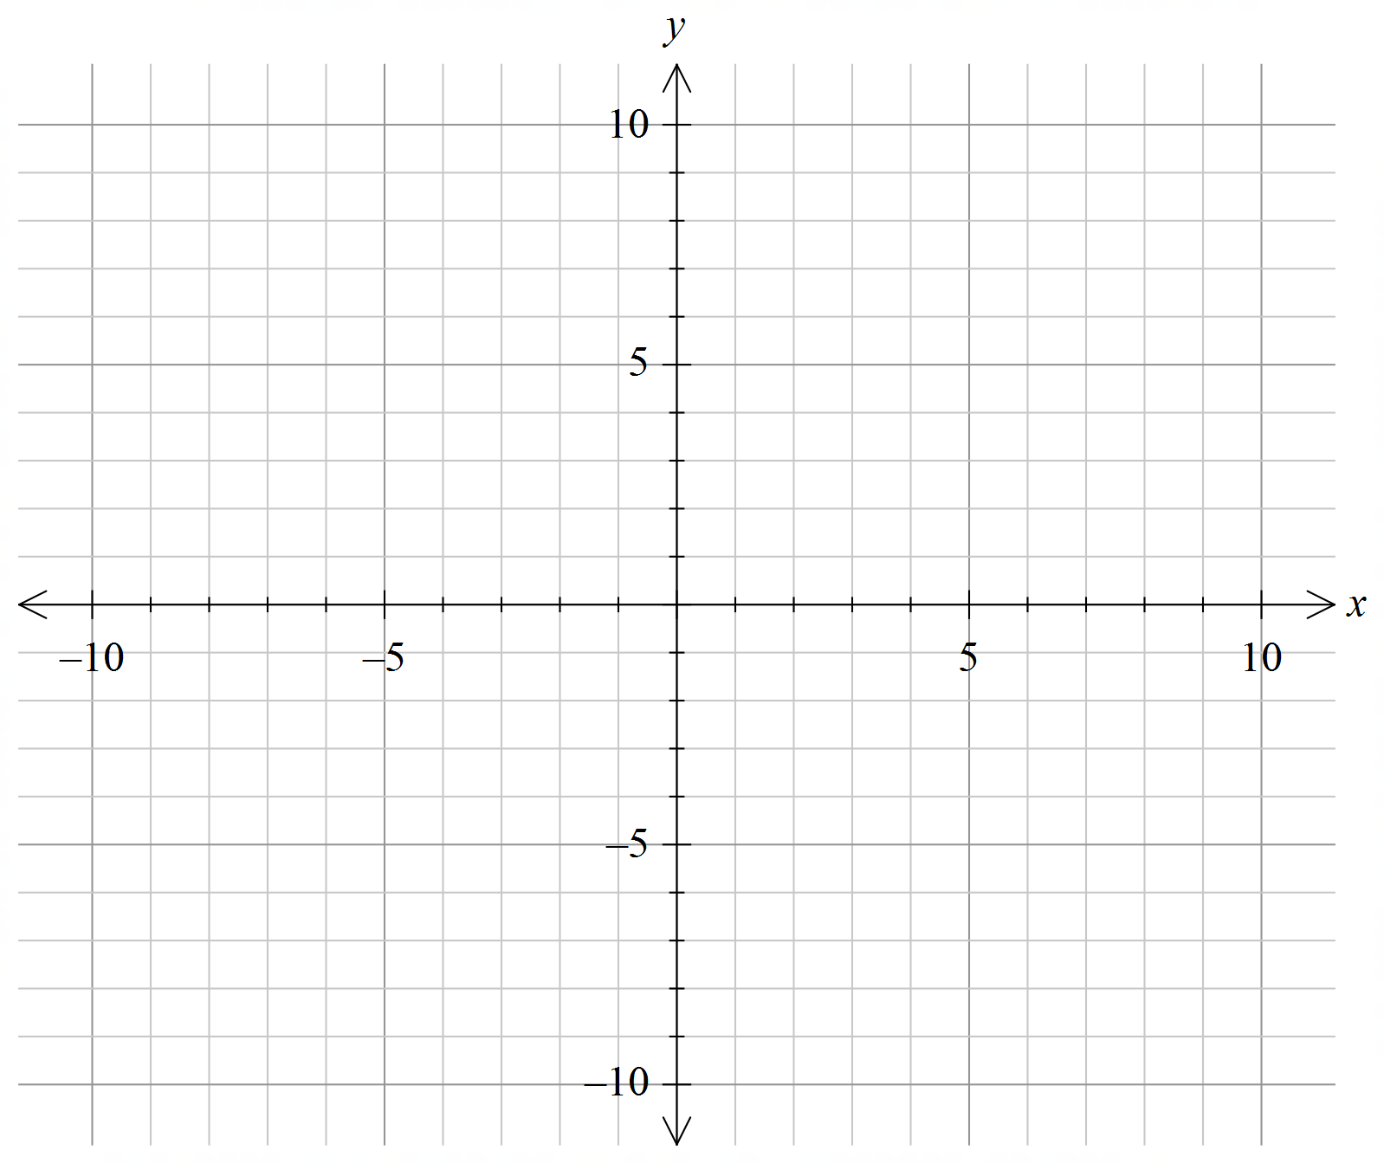

- What are the values of $b$ and $c$?
(2 marks)

- State the domain and range of the function.
(2 marks)

Question 19 (8 marks)
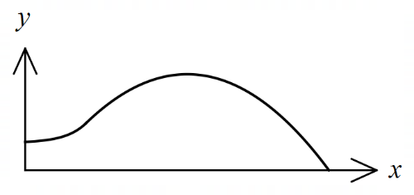
The edges of a swimming pool design, when viewed
from above, are the $x$-axis, the $y$-axis and the curves

$y=-0.1x^{2}+1.6x-1.5$ and $y=1.4+e^{x-3}$

where $x$ and $y$ are measured in metres.

(a) Determine the gradient of the curve at the point where the two curves meet.
(3 marks)

(b) Determine the surface area of the swimming pool.
(4 marks)

(c) Given that the water in the pool has a uniform depth of $145$ cm, determine the capacity of the pool in kilolitres ($1$ kilolitre of water occupies a volume of $1$ m³).
(1 mark)

Question 20 (6 marks)
The moment magnitude scale $M_{w}$ is used by seismologists to measure the size of earthquakes in terms of the energy released. It was developed to succeed the 1930's-era Richter magnitude scale.
The moment magnitude has no units and is defined as $M_{w}=\frac{2}{3}\log_{10}\left(M_{0}\right)-10.7$, where $M_{0}$ is the total amount of energy that is transformed during an earthquake, measured in dyn$∙$cm.

(a) On 28 June 2016, an estimated $2.82×{10}^{21}$ dyn∙cm of energy was transformed during an earthquake near Norseman, WA. Calculate the moment magnitude for this earthquake.
(1 mark)

(b) A few days later, on 8 July 2016, there was another earthquake with moment magnitude 5.2 just north of Norseman. Calculate how much energy was transformed during this earthquake. (2 marks)

(c) Show that an increase of 2 on the moment magnitude scale corresponds to the transformation of 1000 times more energy during an earthquake. (3 marks)

Question 21 (6 marks)

Given that $f\left(-2\right)=-2, f^{'}\left(-2\right)=-1, g\left(-2\right)=4$ and $g^{'}\left(-2\right)=3$, evaluate $h'(-2)$ in each of the following cases:
(a) $h\left(x\right)={\left(f\left(x\right)\right)}^{5}$.
(2 marks)

(b) $h\left(x\right)=\begin{matrix}g(x) \\ \overline{f(x)}\end{matrix}$.
(2 marks)

(c) $h\left(x\right)=g\left(f\left(x\right)\right)$.
(2 marks)

Supplementary page

Question number: _____________________

Supplementary page

Question number: _____________________

